Name……………………………………………Index No…………………Class……….……
Candidates Signature………………Date…………………………………………….……….

231/1
MARKING SCHEME PAPER 1
THEORY
BIOLOGY
TIME: 2 HRS
Kenya certificate of secondary education (K.C.S.E)
- State two effects of drug abuse. (2mks)
- Irresponsible sexual behaviour
- Domestic problems
- Health problems or disorders
- Death
- Blindness
(Mark first 2)
- State two ways by which study of biology fosters international cooperation. (2mks)
- Joint research on production of vaccines/drugs;
- Conservation of ozone layer through signing of international treaties;
- Signing of international treaties about conservation of the environment;
(Mark first 2)
- The diagram below represents a transverse section through a plant organ
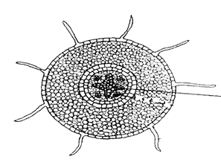
- From which plant organ was the section obtained (1mk)
- (Dicotyledonae ) Root;
- Give two reasons for your answer in (a) above (2mks)
- Presence of root hairs;
- Star shaped xylem;
- The chart below shows a feeding relationship in a certain ecosystem
Green plants
Mice
Hawks
Grass hoppers
Lizards
Snakes
Domestic cat
- Construct the food chains ending with a tertiary consumer in each case. (2mks)
- Green plants grass hopper lizard domestic cat;
- Green plants mice snake hawk;
- Green plants mice snake domestic cat;
- Suggest three ways in which the ecosystem would be affected if there was prolonged drought (3mks)
- Most plants will die/dry up;
- Some animals may starve to death;
- Some organisms may migrate;
- A person was able to read a book clearly at arm’s length, but not at normal distance
- State the eye defect the person suffered from (1mk)
- Long-sightedness/hypermetropia;
- Why was he unable to read the book clearly at normal distance (1mk)
- Image is focussed behind the retina; due to short eyeball; lens unable to focus because they are flat;
- How can the defect be corrected (1mk)
- By wearing convex/biconvex/converging lenses;

- The diagram below shows part of a mammalian respiratory system
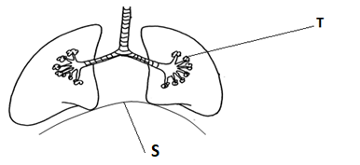
- Explain two ways in which the part labelled T is adapted to its functions (2mks)
- Moist to dissolve respiratory gases;
- Highly vascularized to transport respiratory gases;
- Thin surface for faster diffusion of respiratory gases;

- How does the part labelled S facilitate breathing in (2mks)
Contracts and flattens; increasing the volume of the thoracic cavity;
- Define the term homodont. (1mk)
Animal with teeth of the same type and shape;
- Explain why it is not easy to determine the respiratory quotient in the palisade cells of plants (2mks)
Most carbon (IV) oxide gas produced during respiration; is re used during photosynthesis;
- Explain the events that take place in the human eye when one moves from a poorly lit room to a well-lit room. (3mks)
Circular muscles of the iris contract as radial muscles relax; the diameter of the pupil constricts; allowing less light to enter the eye;
- State three applications of anaerobic respiration in industry. (3mks)
- Brewing
- Bread baking
- Production of fermented milk products
- Production of citric acid
- Vinegar
- Sour porridge
- alcohol to drive engine

- The figure below shows certain organisms. Use the dichotomous key to identify the organisms P, Q and T. (3mks)
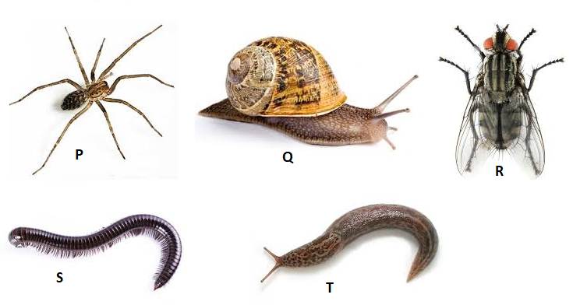

- a) Animal with wings …………………………………………………………… Housefly
b) Animal without wings …………………………………………………………… Go to 2
- a) Animal with walking limbs ………………………………………………………. Go to 3
b) Animal without walking limbs …………………………………………………… Go to 4
- a) Animal with four pairs of walking legs ……………………………………………Spider
b) Animal with more than four pairs of walking limbs ……………………………… Milipede
- a) Animal with shell ………………………………………………………………….. Snail
b) Animal without shell ………………………………………………………………. Slug
Animal | Identity | Steps followed
P | Spider | 1b,2a,3a;
Q | Snail | 1b,2b,4a;
T | Slug | 1b,2b,4b;

- In an experiment, an anti-serum from an animal P was mixed with sera from three other animals in separate test tubes. The heights of precipitates formed was recorded as shown in the diagrams below.
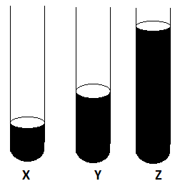
  - Which animal was closely related to animal P? Give a reason. (2mks)
Z; because has the highest precipitate;
  - Which evidence of organic evolution is illustrated above? (1mk)
Comparative serology;
  - What do similarity of wings of bats and those of insects illustrate? (1mk)
Convergent evolution;
- Explain why digestion of starch stops the moment food enters the stomach. (3mks)
The enzyme salivary amylase works best in neutral medium; In the stomach, there is acidity caused by hydrochloric acid; which denatures the enzyme salivary amylase (from the mouth);
- State two functions of the cell sap. (2mks)
Offers turgidity of the cell contributing to mechanical support;
Regulates osmotic pressure of the cell;
Store sugars, ions and waste products of metabolism;
- Distinguish between homologous and analogous structures. (2mks)
Homologous structures are structures of the same embryonic origin that become modified in the course of evolution (due to exploitation of different ecological niches ) to perform different functions; while analogous structure are structures of different embryonic origin that become modified in the course of evolution (due to exploitation of same ecological niches) to perform similar functions;
- In an experiment, 600 flies were caught and marked. After 24 hrs 400 flies were caught out of which 120 had the marks. Estimate the population size of the flies in that habitat. (2mks)
FMXSC/MR
600x400/120;
=2,000 FLIES
- State two functions of the secretion from sebaceous gland of mammalian skin. (2mks)
- It is anti-septic
- Makes the hair and epidermis flexible
- It is waterproof
- State the significance of thigmotropism to a photosynthetic plant. (2mks)
Enables the plant to obtain mechanical support; exposing leaves to sunlight (for photosynthesis);
- An organelle magnified 4000 times by an electron microscope measured 2mm in diameter. Calculate its real diameter in micro-meters. (2mks)
1MM = 1000ųm = 2000ųm –: 4000
2mm = 2 x 1000ųm = 2000ųm
= 2000ųm 4000
= ½ or 0.5ųm
= 0.5ųm
- Which substance causes ripening and falling of fruits (1mk)
Ethylene;
- Below is the general structure of an amino acid
What do the following refer to? (2mks)
-COOH ………Carboxyl group;
-NH₂ …………Amino group;
- State two theories that explain the origin of life on the earth. (2mks)
- Special creation;
- Chemical evolution theory;
- State two ways of breaking seed dormancy. (2mks)
– Allowing the seed grow to maturity.
- Increases the concentration of hormones e.g. cytokins and gibberlins to stimulation germination
- Presence of light of certain wavelength
- Providing favourable conditions like water, air and warmth
- Mechanical rapture of seed coat scarification
-Exposure to heat
- (a) State two roles of the DNA molecule. (2mks)
  - Stores genetic information in a coded form.
  - Enables transfer of genetic information unchanged to daughter cells through replication.
  - Translates the genetic information into the characteristics of an organism through protein synthesis.
(b) A DNA strand sequence had the following base sequence TAC GCT. What is the sequence of M- RNA strand copied from this DNA portion? (1mk)
AUGCGA;
- The diagram below shows a mature pollen grain
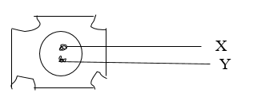
  - State the function of the structure labelled. (2mks)
X Tube nucleus: help in growth of pollen tube and assist in piercing the embryo sac;
Y Generative nucleus: divides mitotically to give rise to two male nuclei;
  - What is meant by double fertilization? (2mks)
One male nuclei fuses with ovum = to form diploid zygote the other nuclei fuses two polar nuclei to form triploid nucleus or primary endosperm.
  - Give two features that hinder self-pollination. (2mks)
- Heterostyly;
- Dioecism;
- Protandry;
- Protogyny
(rej. Self sterility, acc. Dichogamy)
- What will happen to a small section of fresh pumpkin stem placed in hypotonic solution? (3mks)
Inner cells would gain water by osmosis and stretch their walls; the epidermal cells are less permeable hence gain less water; this causes the stem to curve towards the outer side;

- a) A person consumes a lot of sugar in tea. Briefly explain the feedback mechanism in order to bring the sugar level to normal. (3mks)
Pancrease secretes insulin which causes the liver; to convert
- Sugar to glycogen;
- Increase breakdown of glucose to produce energy;
b) What causes diabetes insipidus? (1mk)
Failure by the pituitary gland to secrete enough anti diuretic hormone/vasopressin;
- Given the equation of respiration:
C₆ H₁₂ O₆ 2C₂H₅OH + 2CO₂ + Energy
- Name the type of respiration taking place. (1mk)
Anaerobic;
- Calculate the respiratory quotient (RQ) , use the equation. (2mks)
RQ = Volume of CO₂ (Removed)
Volume of O₂ (consumed)

= 2 = infinity( )
0
- Explain the immediate reaction of the body bathed in cold water. (3mks)
Sweating decrease; Hair is raised; blood kept from the surface and metabolic rate
increases. body temperature raises shivering to generate heat by contraction of muscles.
- Explain why the Lamarckian theory was disputed by scientists. (1mk)
He proposed that phenotypically acquired characteristics are passed on to the offspring;

